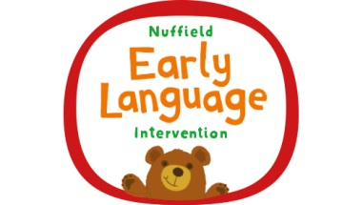
The Nuffield Early Language Intervention
Your child has been chosen to take part in the Nuffield Early Language Intervention, a very successful language programme. He/She will have short daily individual or small group lessons for 20 weeks in which we will learn new words and practise our speaking and listening skills. During weeks 11–10 we focus on letters and sounds too.
What activities will we be doing?
For group sessions we work together with four or five children. We have a character called Ted who joins us and reminds us about how to listen. Every time we meet, we learn new words and phrases and play some games. They are based on topics like My Body, People Who Help Us and Journeys. We also look at stories, either fictional ones or a real-life event, such as going to the doctors or the playground. The children are encouraged to speak in sentences, thinking about what is happening in the pictures and retelling or making up a story. The individual sessions are planned to give the specific support your child needs to learn the new words and develop their language skills.
How can I help at home?
The best way you can help your child at home is to talk with them a lot. This can be about anything from involving them in things that you are doing at home or while you are out and about, to discussing things that your child is interested in. Whenever possible, let them lead the conversation. Repeat some of the things your child says so that they know you are listening, and try adding a couple of words of your own so that you show how to develop their language skills.
Reading books to your child is another great way of helping them to develop their listening and speaking skills. Finding a book that features activities or characters that they already know can help. Children love repetition, so don’t worry if you find yourself reading the same book over and over again! Enjoyment and memory are key parts of learning to read so developing favourites will help lay good foundations for the future.
Each week we will tell you the new words that children have been learning so that you can practise using them at home.
If you have any questions then please call in to the classroom.

